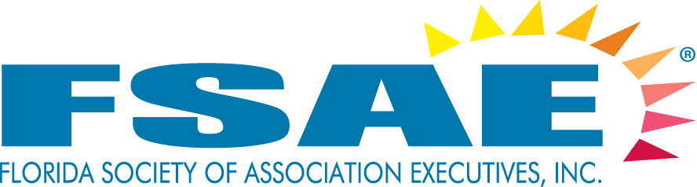

REQUEST FOR PROPOSAL

RESPOND BY October 11, 2024

DATE: 9/9/2024
TO: All FSAE Associate Member Hotels and CVB’s
FROM: Trevor Maddox, CMP
RE: FLORIDA SOCIETY OF ASSOCIATION EXECUTIVES – 2025 Events
# OF PAGES: 16

Florida Society of Association Executives (FSAE) is looking to secure locations for our 2025 events.

A description and the specifications for each of FSAE’s events can be found on the following pages. At the end of this RFP, you will find a Response Form for you to select the event(s) you are interested in hosting, along with space to list your available date(s). We ask that you please avoid Holidays and offer as many dates as you can. This will improve the likelihood your property will be selected for at least one meeting.

I would encourage you to partner with your local CVB and local vendors to enhance your bids and to help offset a portion of the hosting costs.

Please Note:
By agreeing to host an event, it is understood that all guest rooms, except where otherwise indicated, meeting space, A/V, Internet (guestrooms and inside assigned meeting space), parking, resort fees, and Food and Beverage as outlined in the specifications will be provided on a complimentary basis. This is your chance to showcase your property/venue to prospective clients.

In order for your property to be considered for selection the host hotel must have an active FSAE member on staff or be willing to have a staff member join FSAE if their site is chosen.

Send your RFP responses via email using the attached RFP Response Form by October 11, 2024.

For questions regarding this RFP please contact Trevor Maddox, CMP, at 850-702-0942 or trevor@fsae.org
PROFILE: FSAE is the gateway to doing business with the association market in Florida. With over 1,100 executive and associate members in the State of Florida, including those who manage trade and professional associations, individual membership societies, charitable organizations and other not-for-profit organizations, FSAE is the recognized public spokesperson and leading resource for information on associations. Florida associations generate $3.7 billion dollars each year on meetings, travel and operations. These associations support over 88,000 jobs across the state and collectively host over 40,500 meetings annually. Learn more at www.fsae.org.

2025 FSAE Calendar

2025 Events
Time Frame | Location | Event | Notes
January-December | Tampa/Orlando/Southeast Florida | Power Lunch x 2
March-May | Central FL/South FL | One Day Summit
March-May | Jacksonville/St. Augustine (NE FL) | One Day Summit
August – September | Any Florida Location | CEO Retreat
September - October | Any Florida Location | Think Tank
September - November | Any Florida Location | Meeting Planner Forum
November | Central Florida | Power Lunch/  FSAE Board Meeting

MAP
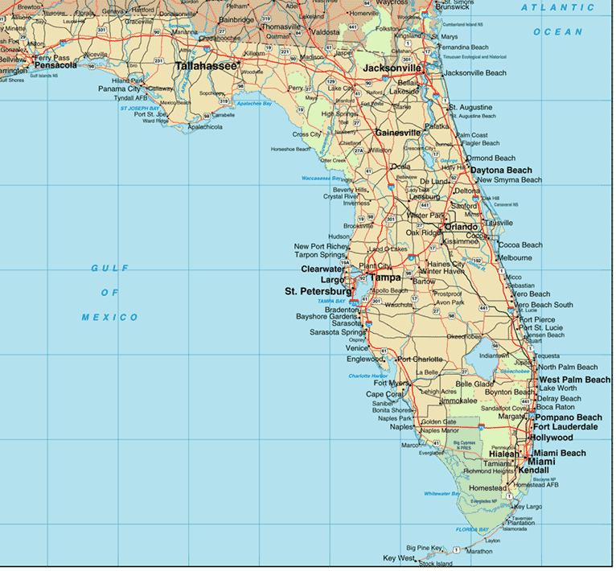
Power Luncheon
January- December
Tuesday, Wednesday or Thursday
(1-day event)
Tampa/Orlando/Southeast Florida
Power Lunch
The purpose of the Power Lunch is to provide a forum for an educational and networking opportunity. Attendance, which usually ranges from 50-75 people, consists of both Executive and Associate members.

Special Notes
By agreeing to host an event, it is understood that all guest rooms, except where otherwise indicated, resort fees, parking, meeting space, A/V, Wi-Fi (guestrooms and inside assigned meeting space), and Food and Beverage as outlined in the specifications will be provided on a complimentary basis.

The host hotel will have an opportunity to welcome the group and will be given recognition on the FSAE Website, in Source magazine, in all FSAE social media and marketing materials related to the sponsored event.

It is highly recommended that an optional tour of the property be conducted after the Power Lunch for those interested in seeing the facility. Participation by the host hotel at the Luncheon (not included in counts below) is welcomed and encouraged.

We ask that properties provide a special pre and post meeting rate for those attendees who would like to arrive before or stay after the scheduled meeting dates.

If a property has a specialty, such as spa or golf, it can be offered at your option for early arrivals or before checkout.

Room Block

 | Evening Prior to Luncheon | Day of Luncheon | Total Room Nights
FSAE Staff/Speaker | 4 | Checkout | 4 Comp
Optional – provide special industry rate for participants of the Power Luncheon
for evening prior to luncheon – historically about 10 rooms.

Tuesday, Wednesday, or Thursday

Function | Time Frame | # of Participants | Setup
Power Luncheon | 11:30 am – 1:00 pm | 50-75pp | Crescent Rounds
Optional Property Tour | 1:00 pm – 2:00 pm

Summit – NEW event in 2025
March - May
Thursday or Friday
(1-day event)
Central and South Florida Location

Summit
The purpose of the Summit is to offer a one-day immersive experience focused on learning and networking. Attendance will range from 50-75 participants, consisting mainly of Executive members and a few Associate members.

Special Notes
By agreeing to host an event, it is understood that all guest rooms, except where otherwise indicated, resort fees, parking, meeting space, A/V, Wi-Fi (guestrooms and inside assigned meeting space), and Food and Beverage as outlined in the specifications will be provided on a complimentary basis.

The host hotel will have an opportunity to welcome the group and will be given recognition on the FSAE Website, in Source magazine, in all FSAE social media and marketing materials related to the sponsored event.

An optional tour of the property is highly recommended during the Summit for those interested in seeing the facility. The host hotel’s participation during lunch (not included in counts below) is welcomed and encouraged.

We ask that properties provide a special pre and post summit rate for those attendees who would like to arrive before or stay after the scheduled summit date.

Room Block

 | Evening Prior to Summit | Evening of Summit |  | Total Room Nights
FSAE Staff/Speakers | 10 | 10 | Checkout Day after Summit | 20 Comp
Summit Attendees | 10 -15 at a discounted rate | 10 -15 at a discounted rate | Checkout Day of Summit | 20 – 30 at a discounted rate

Wednesday or Thursday Evening Before Summit

Function | Time Frame | # of Participants | Setup
Welcome Reception/Networking | 6:30 pm – 7:30 pm | 10-20pp

Summit – Thursday or Friday

Function | Time Frame | # of Participants | Setup
Continental Breakfast & Registration | 9:00 am – 9:30 am | 50-75pp | RDS
Summit | 9::00 am – 4:00 pm | 50-75pp | Crescent RDS
Lunch | 12:00 pm – 1:00 pm | 50-75pp | Crescent RDS
Refreshment Break | 2:15 pm | 50-75pp
Adjourn | 4:00 pm

Summit – NEW event in 2025
March - May
Thursday or Friday
(1-day event)
Jacksonville/St. Augustine (NE FL) Location

Summit
The purpose of the Summit is to offer a one-day immersive experience focused on learning and networking. Attendance will range from 50-75 participants, consisting mainly of Executive members and a few Associate members.

Special Notes
By agreeing to host an event, it is understood that all guest rooms, except where otherwise indicated, resort fees, parking, meeting space, A/V, Wi-Fi (guestrooms and inside assigned meeting space), and Food and Beverage as outlined in the specifications will be provided on a complimentary basis.

The host hotel will have an opportunity to welcome the group and will be given recognition on the FSAE Website, in Source magazine, in all FSAE social media and marketing materials related to the sponsored event.

An optional tour of the property is highly recommended during the Summit for those interested in seeing the facility. The host hotel’s participation during lunch (not included in counts below) is welcomed and encouraged.

We ask that properties provide a special pre and post summit rate for those attendees who would like to arrive before or stay after the scheduled summit date.

Room Block

 | Evening Prior to Summit | Day of Summit | Total Room Nights
FSAE Staff/Speaker | 10 | Checkout | 10 Comp
Summit Attendees | 10 - 15 at a discounted rate | Checkout | 10 -15 at a discounted rate

Wednesday or Thursday Evening Before Summit

Function | Time Frame | # of Participants | Setup
Welcome Reception/Networking | 6:30 pm – 7:30 pm | 10-20pp

Summit – Thursday or Friday

Function | Time Frame | # of Participants | Setup
Continental Breakfast & Registration | 9:00 am – 9:30 am | 50-75pp | RDS
Summit | 9:30 am – 4:00 pm | 50-75pp | Crescent RDS
Lunch | 12:00 pm – 1:00 pm | 50-75pp | Crescent RDS
Refreshment Break | 2:15 pm | 50-75pp
Adjourn | 4:00 pm
(1) CEO Retreat
August-September
(2-day event)
Friday - Sunday
All Florida Locations Will Be Considered

The CEO Retreat provides attendees with an informal and confidential setting to discuss association issues and trends. Attendees are the Association’s key decision makers, the Chief Executive Officer, President or Executive Director. Other than the possibility of one or two speakers, only individuals from an association are invited and allowed to participate. FSAE will screen all applicants for eligibility.

Invited attendees are limited to 30 Executives. Each attendee is allowed to bring one adult spouse/guest (no children allowed). Approximately half the attendees bring a guest. Guests are invited to a reception and dinner on Friday evening, Saturday dinner and the Saturday morning breakfast, but do not attend the meeting or partake in breaks or lunch Saturday.

Special Notes
By agreeing to host an event, it is understood that all guest rooms, resort fees, parking, meeting space, A/V, Wi-Fi (guestrooms and inside assigned meeting space), and Food and Beverage as outlined in the specifications will be provided on a complimentary basis.

The host hotel will have an opportunity to welcome the group and will be given recognition on the FSAE Website, in Source magazine, in all FSAE social media and marketing materials.

It is highly recommended that a tour of the property be conducted on Friday or Saturday evening. Participation by the host hotel at certain meal functions (not included in counts below) is welcomed and encouraged. Dinners can be done in your hotel restaurants instead of private banquet rooms to avoid additional labor costs allowing the group the opportunity to experience the ambiance of your outlets.

We ask that properties provide a special pre- and post-meeting rate for those attendees who would like to arrive before or stay after the scheduled meeting dates.

If a property has a specialty, such as spa or golf, it can be offered at your option for early arrivals or before checkout.

Room Block

 | Fri | Sat | Sun | Total Room Nights
FSAE Staff/Speaker | 2 | 2 | Checkout | 4 Comp
CEO Retreat Attendees | 30 | 30 | Checkout | 60 Comp

Friday

Function | Time Frame | # of Participants | Setup
Retreat Kick Off Meeting | 4:00 – 6:00 pm | 30-40pp
Welcome Reception | 6:30 pm – 7:30 pm | 30-40pp
Dinner | 7:30 pm – 9:00 pm | 30-40pp | RDS

Saturday

Function | Time Frame | # of Participants | Setup
Breakfast Buffet | 8:00 am – 9:00 am | 30-40pp | RDS
Meeting | 9:00 am – 5:00 pm | 32pp | U Shape
Lunch | 12:00 pm – 1:00 pm | 32pp | RDS
Refreshment Break | 2:15 pm | 32pp
Reception | 6:30 pm – 7:00 pm | 30-40pp
Property Tour (suggested/optional) | 7:00 pm – 7:30 pm | 30-40pp
Dinner | 7:30 pm – 9:00 pm | 30-40pp | RDS

Sunday

Function | Time Frame | # of Participants | Setup
Breakfast on own – Voucher or credit to room to be provided by host hotel | 8:00 am – 10:00 am | 30-40pp

FSAE FOUNDATION THINK TANK
September or October (Avoid 1st 2 weeks of October)
(2-day event)
Wednesday - Friday
All Florida Locations Will Be Considered

The purpose of the FSAE Foundation Think Tank is to gather senior executives who are association decision makers to contemplate an issue, concern, topic, or idea concerning the operation of associations and/or the association management profession. The group, with the assistance of a facilitator(s), draws conclusions and drafts a report; thereby contributing to the body of knowledge about association management. Other than the speaker(s), only individuals from an association or AMC are invited and allowed to participate. FSAE screens all applicants for eligibility.

Invited attendees are limited to 40-50 Executives. Each attendee is allowed to bring one adult spouse/guest (no children allowed). Approximately half the attendees bring a guest. Guests are invited to the reception and dinner the Wednesday and Thursday and the breakfast Thursday morning. Guests do not attend the Think Tank meeting itself or partake in breaks or lunch on the event day.

Special Notes
By agreeing to host the Think Tank, it is understood that all guest rooms, except for those reserved for staff and speakers will be at a $109 discounted room rate. Parking, meeting space, audio visual, Wi-Fi in guest rooms and meeting space, as well as food & beverage as outlined in the specifications will be provided on a complimentary basis.

Host hotel will have an opportunity to welcome the group and will be given recognition on the FSAE Website, in Source magazine, and in all FSAE social media and marketing materials.

It is highly recommended that a tour of the property be conducted on Wednesday or Thursday evening. Participation by the host hotel at certain meal functions (not included in counts below) is welcomed and encouraged. Dinners can be done in your hotel restaurants instead of private banquet rooms to avoid additional labor costs allowing the group the opportunity to experience the ambiance of your outlets.

We ask that properties provide a special 3-Day pre- and post-rate for those attendees who would like to arrive before or stay after the scheduled meeting dates.

If a property has a specialty, such as spa and golf, it can be offered at your option during scheduled meeting dates and pre-post.

Room Block

 | Wed | Thu | Fri | Total Room Nights
FSAE Staff/Speakers | 10 | 10 | Checkout | 20 Comp
Think Tank Attendees | 50 | 50 | Checkout | $109 room rate

Wednesday
Function | Time Frame | # of Participants | Setup
Welcome Reception | 6:30 pm – 7:30 pm | 50-55pp
Dinner | 7:30 pm – 9:00 pm | 50-55pp | RDS

Thursday

Function | Time Frame | # of Participants | Setup
Breakfast | 8:00 am – 9:00 am | 50-55pp | RDS
General Session | 9:00 am – 5:00 pm | 40 - 50pp | HS
Break | 10:15 am | 40- 50pp
Luncheon | 12:00 pm – 1:00 pm | 40pp | RDS
Break | 2:15 pm | 40pp
Reception | 6:30 pm – 7:30 pm | 60-70pp
Property Tour | 7:30 pm – 8:00 pm | 60-70pp
Dinner | 7:30/8:00 pm – 9:00 pm | 60-70pp | RDS

Friday

Function | Time Frame | # of Participants | Setup
Breakfast on own | 8:00 am – 10:00 am | 50-55pp | RDS

(1) Meeting Planner Forum
September - November
(2-day event)
Friday - Sunday
All Florida Locations Will Be Considered

The Meeting Planner Forum provides attendees with an informal and confidential setting to discuss new ideas and current challenges with a small group of their peers. Attendees are association staff who are directly responsible for planning meetings; most have titles of Meeting Planner, Director of Events, or Director of Education. FSAE will screen all applicants for eligibility.

Invited attendees are limited to 30 Executives. Each attendee is allowed to bring one adult spouse/guest (no children allowed). Approximately half the attendees bring a guest. Guests are invited to a reception and dinner on Friday and Saturday evening and the Saturday morning breakfast, but do not attend the meeting or partake in breaks or lunch Saturday.

Special Notes
By agreeing to host an event, it is understood that all guest rooms, resort fees, parking, meeting space, A/V, Wi-Fi (guestrooms and inside assigned meeting space), and Food and Beverage as outlined in the specifications will be provided on a complimentary basis.

The host hotel will have an opportunity to welcome the group and will be given recognition on the FSAE Website, in Source magazine, in all FSAE social media and marketing materials.

It is highly recommended that a tour of the property be conducted on Friday or Saturday evening. Participation by the host hotel at certain meal functions (not included in counts below) is welcomed and encouraged. Dinners can be done in your hotel restaurants instead of private banquet rooms to avoid additional labor costs allowing the group the opportunity to experience the ambiance of your outlets.

We ask that properties provide a special pre- and post-meeting rate for those attendees who would like to arrive before or stay after the scheduled meeting dates.

If a property has a specialty, such as spa or golf, it can be offered at your option for early arrivals or before checkout.

Room Block

 | Fri | Sat | Sun | Total Room Nights
FSAE Staff/Moderator | 2 | 2 | Checkout | 4 Comp
Meeting Planner Forum Attendees | 30 | 30 | Checkout | 60 Comp

Friday

Function | Time Frame | # of Participants | Setup
Welcome Reception and Property Tour | 6:30 pm – 7:30 pm | 30-40pp
Dinner | 8:00 pm – 9:00 pm | 30-40pp | RDS

Saturday

Function | Time Frame | # of Participants | Setup
Breakfast Buffet | 8:00 am – 9:00 am | 30-40pp | RDS
Meeting | 9:00 am – 5:00 pm | 31pp | U Shape
Lunch | 12:00 pm – 1:00 pm | 31pp | RDS
Refreshment Break | 2:15 pm | 31pp
Reception | 6:30 pm – 7:30 pm | 30-40pp
Dinner | 7:30/8:00 pm – 9:00 pm | 30-40pp | RDS

Sunday

Function | Time Frame | # of Participants | Setup
Breakfast on own – Voucher to be provided by host hotel | 8:00 am – 10:00 am | 30-40pp

Power Lunch/FSAE and Foundation Board Meetings
November
(2-day event)
Tuesday – Wednesday or Wednesday-Thursday
Central Florida Location

Power Lunch
The purpose of the Power Lunch portion of the program is to provide a forum for an educational and networking opportunity. Attendance, which usually ranges from 75-100 people, consists of both Executive and Associate members.

FSAE Board Meetings
The FSAE Board of Directors are charged with building highly effective organizations. They are led by skilled leaders who maintain fiscal stability and viability. Their focus is the success for our members and our profession through professional development, research, education, publications and public relations efforts for the association management profession.

The Board is comprised of 20 individuals. The FSAE Board Member is allowed to bring one spouse/guest (approximately half the board attendees bring a guest, and no children are allowed). Guests are invited to attend the Wednesday Reception and Dinner.

Special Notes
By agreeing to host an event, it is understood that all guest rooms, except where otherwise indicated, resort fee, parking, meeting space, A/V, Wi-Fi (guestrooms and inside meeting rooms), and Food and Beverage as outlined in the specifications will be provided on a complimentary basis.

The host hotel will have an opportunity to welcome the group and will be given recognition on the FSAE Website, in Source magazine, in all FSAE social media and marketing materials.

It is highly recommended that a tour of the property be conducted on Wednesday evening. Participation by the host hotel at certain meal functions (not included in counts below) is welcomed and encouraged. Dinners can be done in your hotel restaurants instead of private banquet rooms to avoid additional labor costs allowing the group the opportunity to experience the ambiance of your outlets.

We ask that properties provide a special pre- and post-meeting rate for those attendees who would like to arrive before or stay after the scheduled meeting dates,

Room Block

 | Evening Prior Lunch |  | Day of Lunch | Total Room Nights
FSAE Staff | 6 |  | Checkout | 6 Comp
FSAE Board Members | 15-20 |  | Checkout | 15-20 Comp
Optional – provide special industry rate for participants of the Power Luncheon for evening prior to luncheon– historically about 5 rooms.

Tuesday or Wednesday

Function | Time Frame | # of Participants | Setup
Kick off Board Meeting | 3:00 pm – 6:00 pm | 26 pp
Welcome Reception | 6:00 pm – 7:00 pm | 30 pp | Reception
Hotel Site Tour | 7:00 pm – 7:30 pm | 30 pp | Tour
Dinner | 7:30 pm – 9:30 pm | 30 pp | RDS

Wednesday or Thursday

Function | Time Frame | # of Participants | Setup
Buffet Breakfast | 7:30 am – 8:30 am | 20-25 pp | RDS
Board Meeting | 8:30 am – 11:30 am | 25pp | HS
Refreshment Break | 10:00 am | 25pp
Power Luncheon | 11:30 am – 1:00 pm | 75-100pp | RDS

Previous FSAE/FSAE Foundation Meeting Hosts

Previous host of FSAE and FSAE Foundation events can attest to the value of the investment
of bringing these groups to their properties. For your reference you will find below a brief list of some
of the properties that have hosted one of the FSAE or FSAE Foundation events.

B Ocean Ft. Lauderdale
Boca Raton Resort & Club
Busch Gardens Tampa Bay
Caribe Royale Orlando
Casa Marina
Disney’s Boardwalk
Doubletree Orlando Resort
El Conquistador (Puerto Rico)
Embassy Suites by Hilton Lake Buena Vista South
Embassy Suites Tampa USF
Four Seasons Resort Palm Beach
Hammock Beach Resort
Hard Rock Hotel Daytona Beach
Hilton Cocoa Beach Oceanfront
Hilton Orlando
Hilton Orlando / Altamonte Springs
Hilton San Destin Beach Golf Resort & Spa
Hyatt Place Panama City Beach
Hyatt Regency Bonaventure
Hyatt Regency Coconut Point
Hyatt Regency Jacksonville Riverfront
Hyatt Regency Sarasota
Innisbrook Resort
Lowes Don CeSar
Lowes South Beach
Marco Island Marriott
Margaritaville Resort Orlando
Marriott Bay Point
Mission Inn
Naples Beach Hotel & Golf Club
Omni Champions Gate
Pelican Grand Beach Resort
PGA National Resort & Spa
Plantation Inn
Plaza Resort Daytona
Registry Resort
Renaissance Orlando at Sea World
Renaissance Plantation
Renaissance Vinoy Resort
Riverside Hotel
Rosen Centre Hotel
Royal Caribbean Cruise Lines
SanDestin Resort
Safety Harbor Resort & Spa
Seminole Hard Rock Tampa
Sheraton Suites Fort Lauderdale at Cypress Creek
Sirata Beach Resort
Sonesta Fort Lauderdale
South Seas Island Resort
The Breakers, Palm Beach
The DAYTONA, a Marriott Autograph Collection Hotel
The Grove Resort & Spa
The Peabody Orlando
The Villas of Grand Cypress
Trade Winds Island Grand
Watercolor Resort
Westin Fort Lauderdale Beach Resort
Westin Imagine Hotel
World Equestrian Center
Wyndham Grand Jupiter at Harbourside Place
Wyndham Orlando Resort International Drive
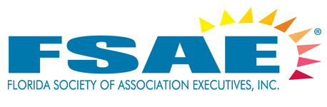

EMAIL: trevor@fsae.org RE: Florida Society of Association Executives – 2025 Events

RFP Response Form - RESPOND BY October 11, 2024

Hotel Name:
Sales Contact: |  | Title:
Email: |  | Phone:

By placing available dates in the right-hand column, you are confirming availability for that date and agree to provide all the guest rooms, except where otherwise indicated in the RFP, resort fee, parking, meeting space, A/V, Wi-fi (guestrooms and inside assigned meeting space) and Food and Beverage as outlined in the specifications for that particular meeting on a complimentary basis. Bidding on more than one event increases the likelihood your property will be selected.

2025 Events
Time Frame | Location | Event | Dates
January-December | Tampa/Orlando/Southeast Florida | Power Lunch x 2
March -May | Central or South Florida | One Day Summit
March - May | Jacksonville/St. Augustine (NE FL) | One Day Summit
August-September | Any Florida location | CEO Retreat
September - October | Any Florida Location | Think Tank
September - November | Any Florida Location | Meeting Planner Forum
November | Central Florida | Power Lunch/  FSAE Board Meeting/

Extras:
Would you like to offer any additional services on a comp basis (spa, golf, spouse/guest tours)?
Tell us about your recent renovation’s awards, and reasons to consider your property.
If you’re bidding on an event that requests an industry rate for those not covered by the comp roomnights, or a rate for pre/post stays, please indicate the rate.

